**Reverse A List:**

CODE:

my_list = [1, 2, 3, 4, 5]  
  
for i in range(len(my_list) - 1, -1, -1):  
 print(my_list[i])

OUTPUT:

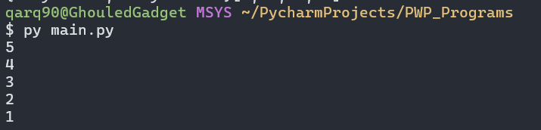

**Sort A List:**

CODE:

my_list = [64, 34, 25, 12, 22, 11, 90]  
  
n = len(my_list)  
for i in range(n):  
 for j in range(0, n-i-1):  
 if my_list[j] > my_list[j+1]:  
 my_list[j], my_list[j+1] = my_list[j+1], my_list[j]  
  
print("Ascending list:", my_list)  
  
for i in range(n):  
 for j in range(0, n-i-1):  
 if my_list[j] < my_list[j+1]:  
 my_list[j], my_list[j+1] = my_list[j+1], my_list[j]  
  
print("Descending list:", my_list)

OUTPUT:

